- Create MariaDB DB on EC2.
Prerequisites
- AWS Account
- EC2 Instance (Amazon Linux 2023)
- SSH access to EC2
- Security Group:
- Port 22 (SSH)
- Port 3306 (MariaDB, if remote access is needed)
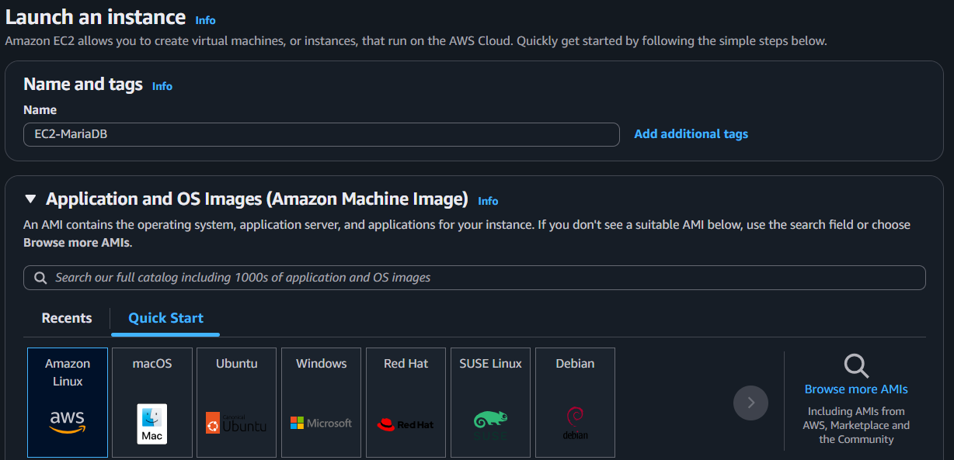
Steps
1. Connect to EC2
ssh -i your-key.pem ec2-user@<EC2-Public-IP>
2. Update the Server
sudo dnf update -y
3. Install MariaDB
sudo dnf install mariadb105-server -y
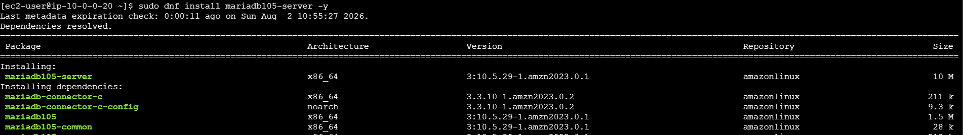
4. Start and Enable MariaDB
sudo systemctl start mariadb
sudo systemctl enable mariadb
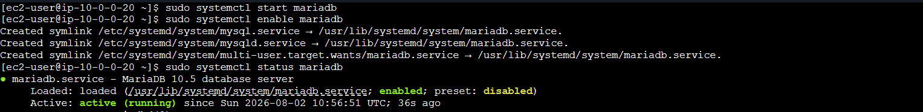
5. Secure MariaDB
sudo mysql_secure_installation
6. Login to MariaDB
sudo mysql -u root -p
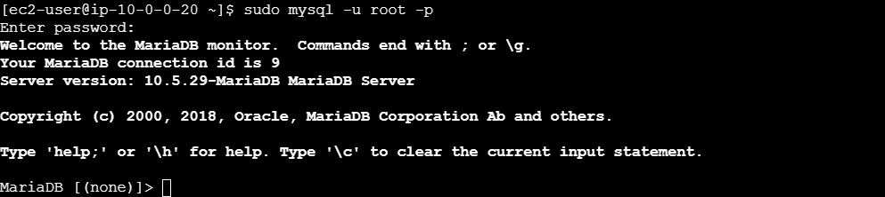
Result: MariaDB is installed, running, and the companydb database is created successfully.

- Insert some dummy data.
1. Login to MariaDB
sudo mysql -u root -p
- Create a Database
Create database companydb;
3. Use the Database
USE companydb;
4. Create a Table
CREATE TABLE employees (
id INT AUTO_INCREMENT PRIMARY KEY,
name VARCHAR(100),
department VARCHAR(50),
salary DECIMAL(10,2)
);
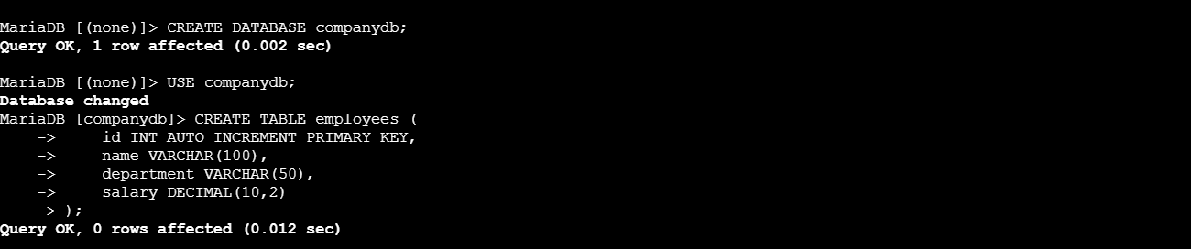
5. Insert Dummy Data
INSERT INTO employees (name, department, salary)
VALUES
('Satish', 'DevOps', 70000),
('Rahul', 'AWS', 65000),
('Priya', 'HR', 50000);
6. Verify the Data
SELECT * FROM employees; 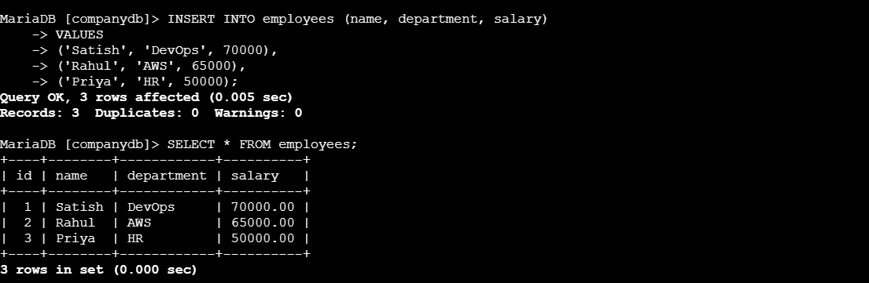
Flow:
Login → Create Database → Use Database → Create Table → Insert Data → Verify Data
- Take the backup of dummy data on EC2.
Prerequisites
- MariaDB installed and running
- Database created (e.g., companydb)
- Dummy data inserted

Step 1: Login to EC2
ssh -i your-key.pem ec2-user@<EC2-Public-IP>

Step 2: Create a Backup Directory
mkdir -p ~/db-backups 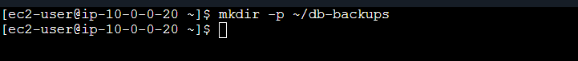

Step 3: Take Database Backup
sudo mysqldump -u root companydb > companydb_backup.sql
- Enter the MariaDB root password when prompted.
- This creates a backup file named companydb_backup.sql.

Step 4: Verify the Backup File
ls -lh ~/db-backups/
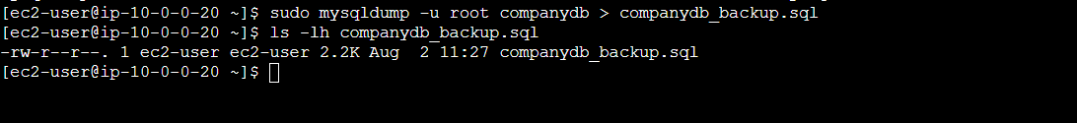

Result
The companydb database, including its tables and dummy data, is backed up successfully to:
~/db-backups/companydb_backup.sql

- Launch MariaDB RDS instance.
Prerequisites
- AWS Account
- VPC with 2 subnets
- Security Group (Port 3306 open)
Steps
- Go to AWS Console → RDS → Create Database.
- Select Standard Create.
- Choose MariaDB.
- Select Free Tier template.
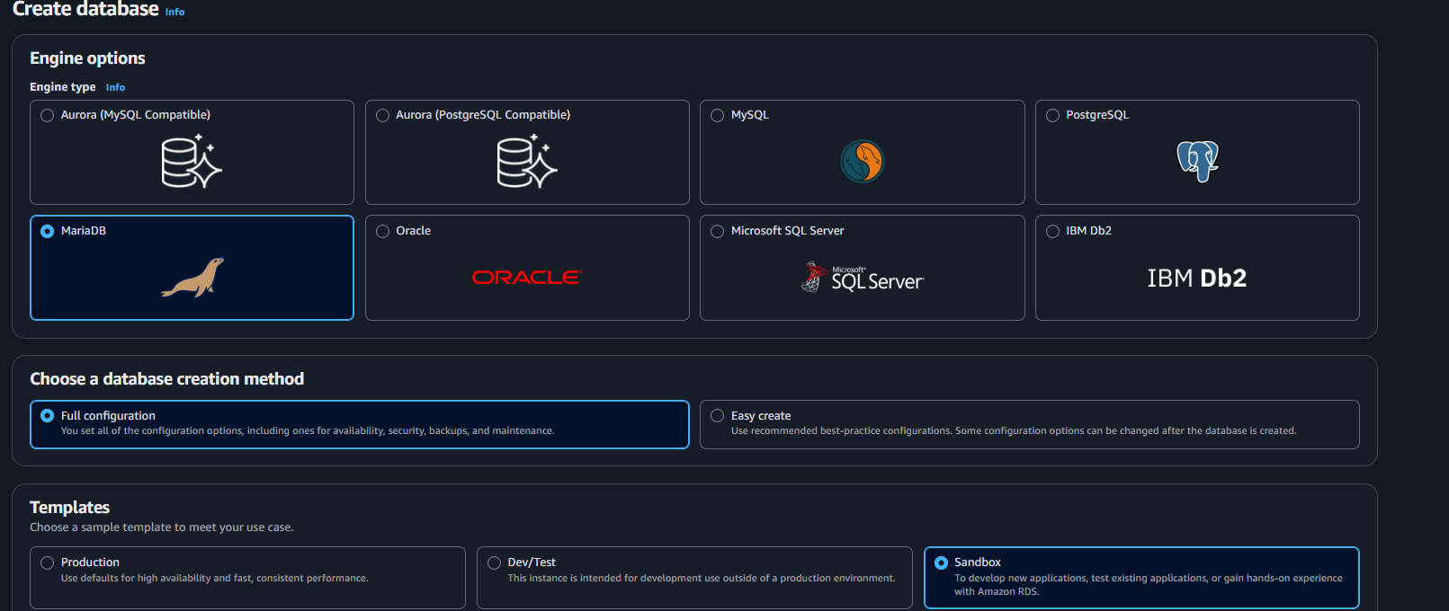
- Enter:
  - DB Identifier: mariadb-demo
  - Username: admin
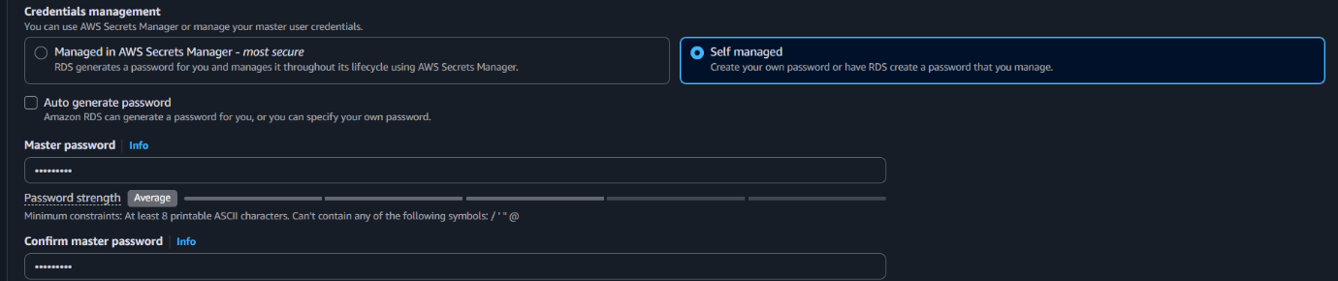
  - Password: ********

- Choose db.t3.micro instance class.
- Allocate 20 GB storage.
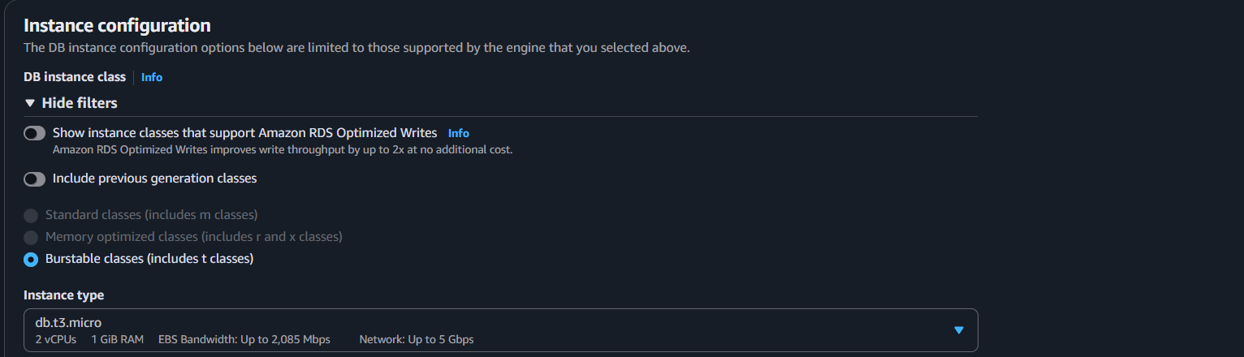
- Select your VPC and Security Group.
- (Optional) Enter Initial Database Name: companydb.
- Click Create Database.
- Wait until the status is Available.
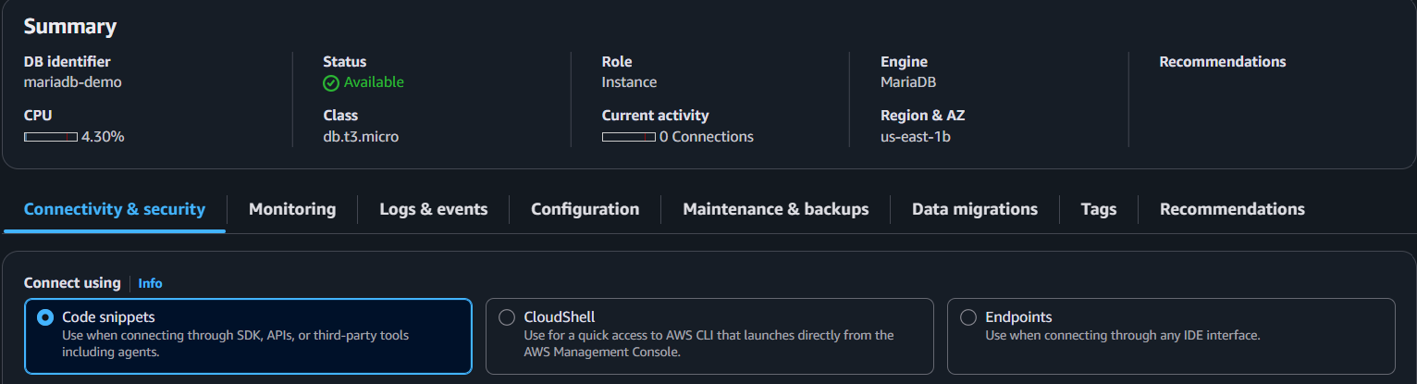
Verify
Copy the RDS Endpoint and connect:
mysql -h <RDS-endpoint> -P 3306 -u admin -p
Result: MariaDB RDS instance is created and ready to use. 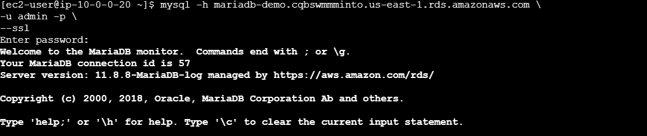

- Migrate database from EC2 to RDS.
Prerequisites
- MariaDB running on EC2
- MariaDB RDS instance created
- Backup file (companydb_backup.sql)
- RDS Security Group allows TCP 3306 from the EC2 Security Group or EC2 IP

Steps
1. Take Backup on EC2
sudo mysqldump -u root companydb > companydb_backup.sql
2. Copy the RDS Endpoint
Go to RDS → Databases → Your DB → Endpoint.
3. Connect to RDS
mysql -h <RDS-endpoint> -P 3306 -u admin -p
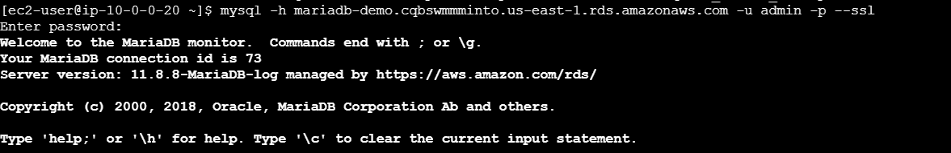
4. Create the Database on RDS
CREATE DATABASE companydb;
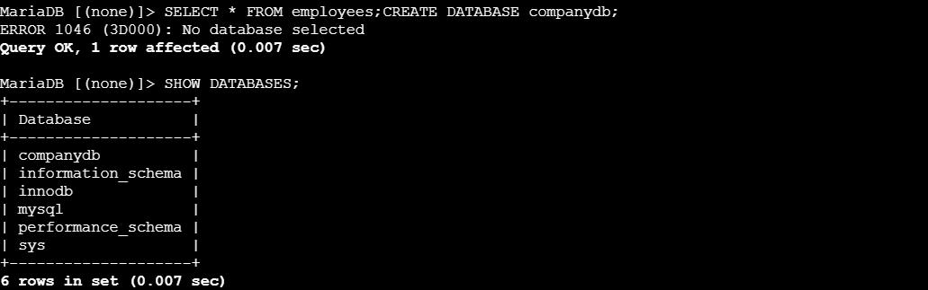
EXIT;
- Restore the Backup to RDS
Run this from the EC2 terminal (not inside the MariaDB prompt):
mysql -h <RDS-endpoint> -P 3306 -u admin -p companydb < companydb_backup.sql
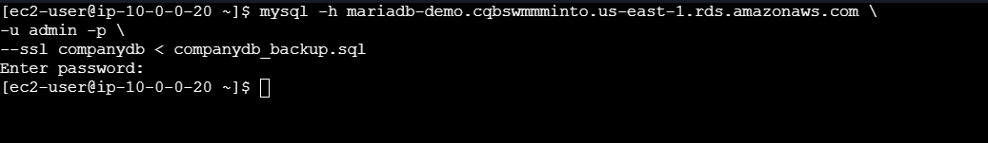
6. Verify the Data
mysql -h <RDS-endpoint> -P 3306 -u admin -p
USE companydb;
SHOW TABLES;
SELECT * FROM employees;
Result
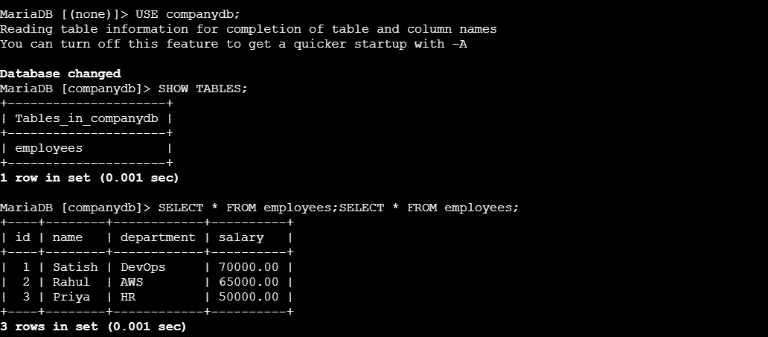
The companydb database and its data are successfully migrated from EC2 MariaDB to Amazon RDS MariaDB.

- Install MySQL DB on EC2.
Prerequisites
- EC2 instance (Amazon Linux 2023)
- SSH access
- sudo privileges
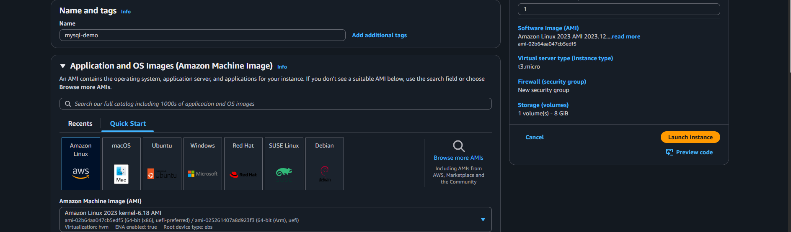
Step 1: Update the System
sudo dnf update -y
Step 2: Install MySQL Server
sudo dnf install mysql-server -y
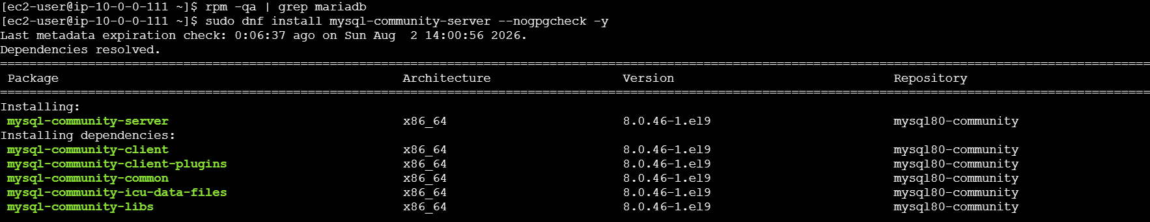
Step 3: Start MySQL Service
sudo systemctl start mysqld
Step 4: Enable MySQL at Boot
sudo systemctl enable mysqld
Step 5: Check Service Status
sudo systemctl status mysqld 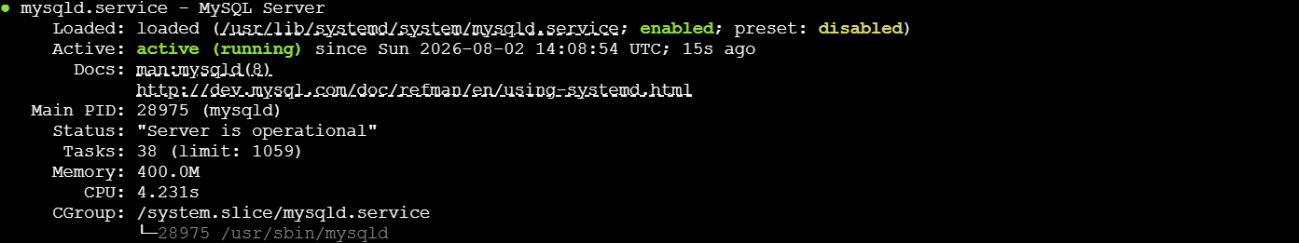
Step 6: Secure MySQL Installation (Optional)
sudo mysql_secure_installation
Step 7: Login to MySQL
sudo mysql -u root -p
Result: MySQL is installed and ready to use on your EC2 instance.

- Launch MySQL RDS image.
Prerequisites
- AWS Account
- VPC and Subnets
- Security Group allowing TCP 3306
- Master username and password

Step 1: Open Amazon RDS
- AWS Console → RDS
- Click Create database
Step 2: Choose Database
- Standard Create
- Engine: MySQL
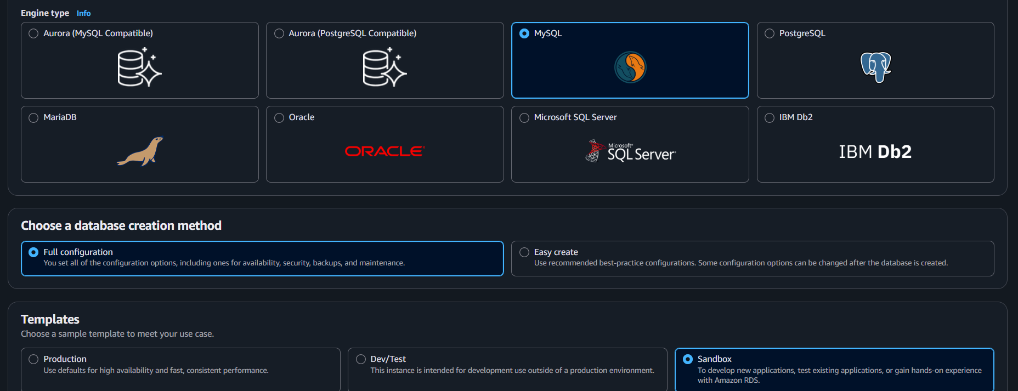
Step 3: Select Version
- Choose the latest MySQL 8.x version (default)
Step 4: Configure DB
- DB Instance Identifier: mysql-demo
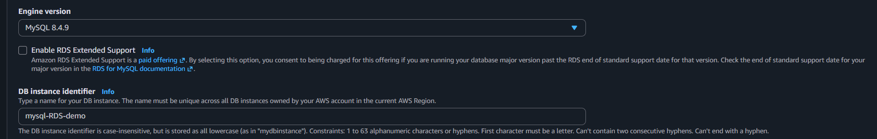
- Master Username: admin
- Master Password: Create a strong password
Step 5: Instance Configuration
- DB Instance Class: db.t3.micro (Free Tier eligible, if available)
Step 6: Storage
- Storage Type: General Purpose SSD (gp3)
- Allocated Storage: 20 GB
Step 7: Connectivity
- Select your VPC
- Public Access: Yes (for lab/testing)
- Attach a Security Group with TCP Port 3306 allowed from your EC2 Security Group or IP address.
Step 8: Additional Configuration
- Initial Database Name: companydb (optional)
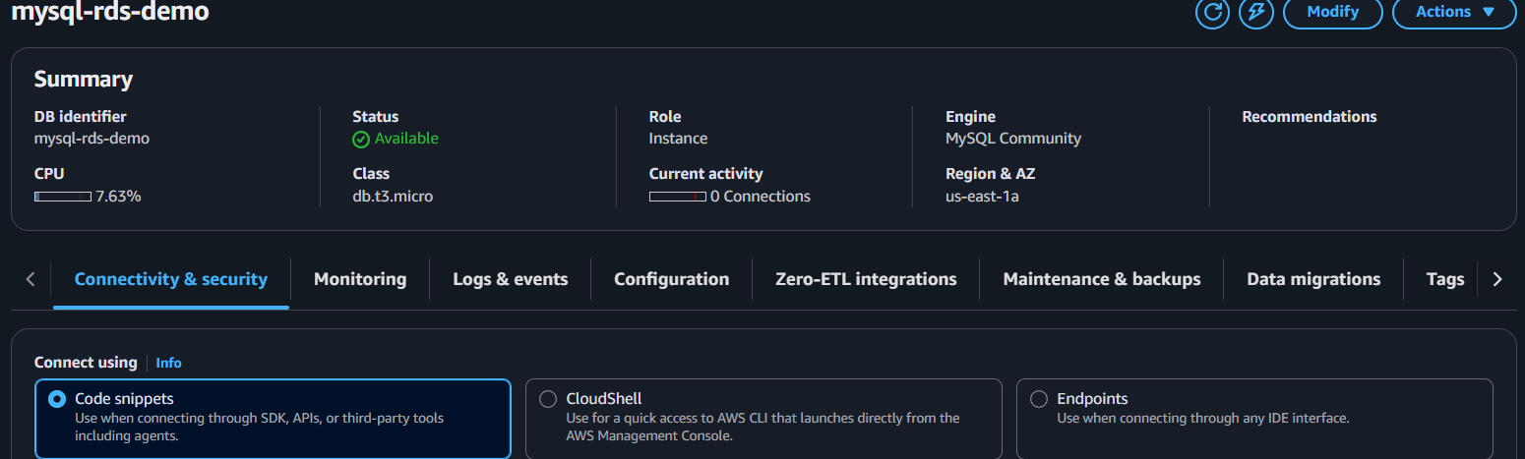

Step 9: Create Database
- Click Create database.
- Wait until the status changes to Available.
Step 10: Connect from EC2
mysql -h <RDS-endpoint> -P 3306 -u admin -p --ssl
Replace <RDS-endpoint> with your MySQL RDS endpoint. 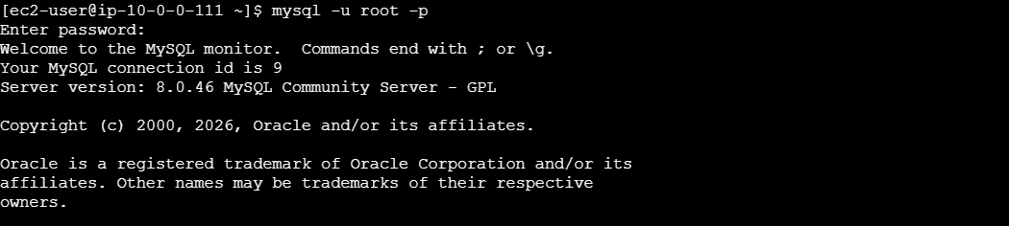
Result: Your MySQL RDS instance is created and ready to accept connections from your EC2 instance.
- Configure Multi-AZ.
- Go to AWS Console → RDS
- Select your MySQL DB instance
- Click Modify
- Under Availability & durability
  - Enable:
Multi-AZ deployment
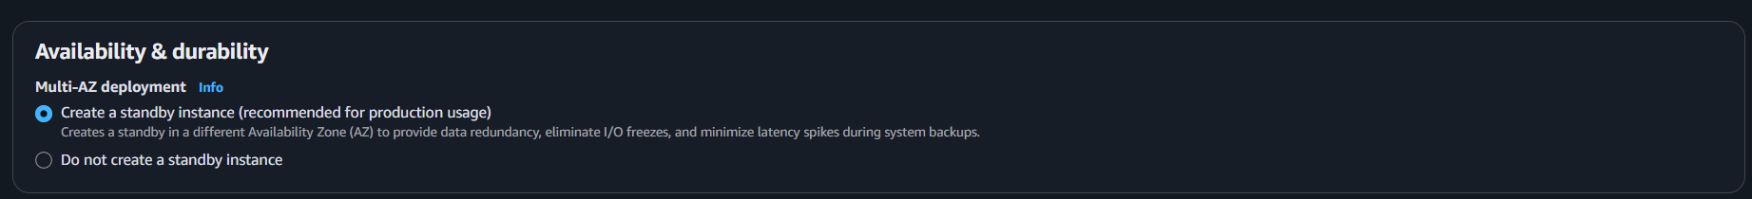
- Choose:
Apply immediately
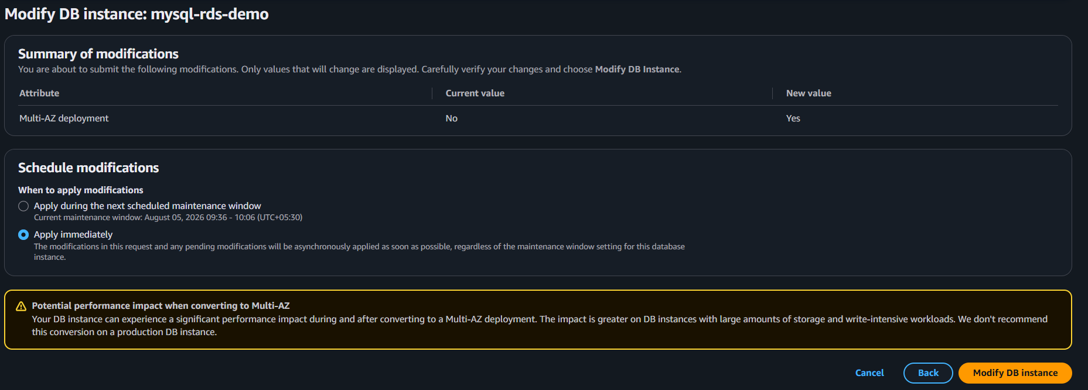
- Click Continue → Modify DB Instance
AWS will create a standby replica in another AZ.
Verify:
RDS → Databases → Your DB → Configuration
You should see:
Multi-AZ: Yes
Primary AZ: us-east-1a
Standby AZ: us-east-1b
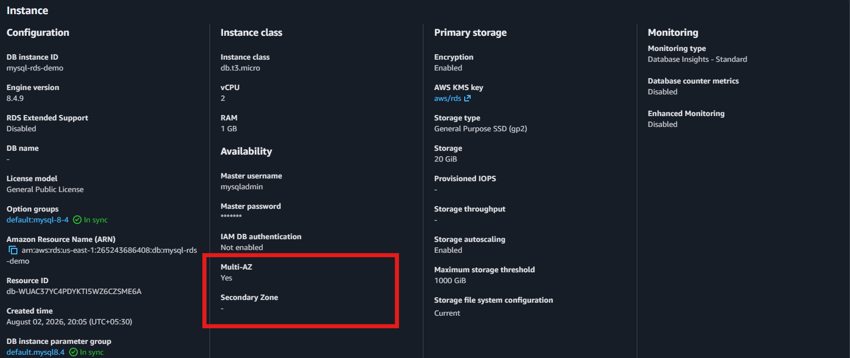
Architecture:
Application
|
RDS Endpoint
|
-------------------
| |
Primary Standby
AZ-1 AZ-2
(Read/Write) (Synchronous)
No manual replication is required; AWS manages failover automatically.

- Take backup of DB and restore the DB.
- Go to AWS Console → RDS
- Select your MySQL DB instance
- Click Actions → Take snapshot
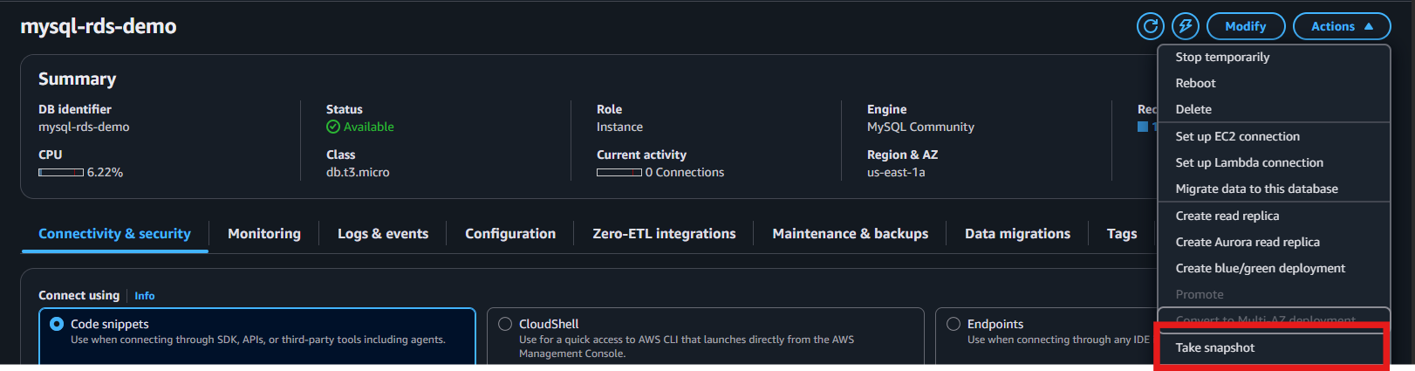
- Enter snapshot name
- Click Take Snapshot
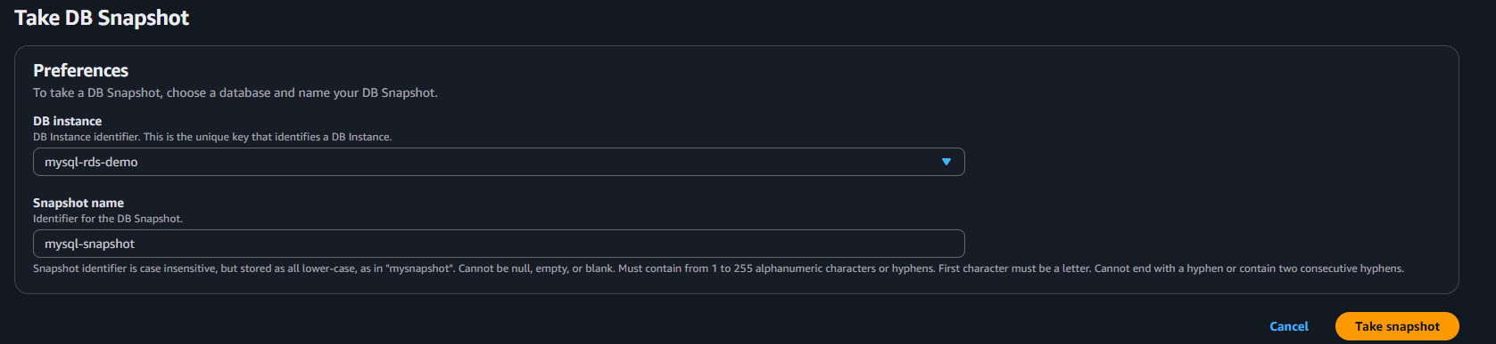

Check:
RDS → Snapshots → Available 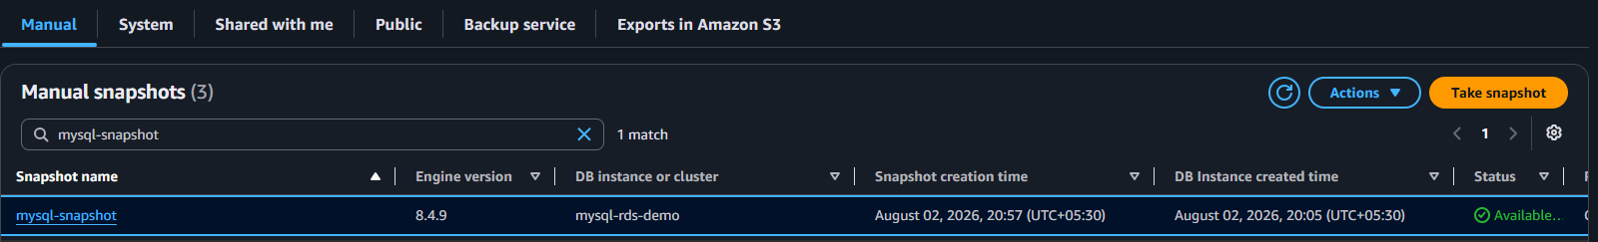

2. Restore Database from Snapshot
- Go to RDS → Snapshots
- Select the snapshot
- Click Actions → Restore snapshot
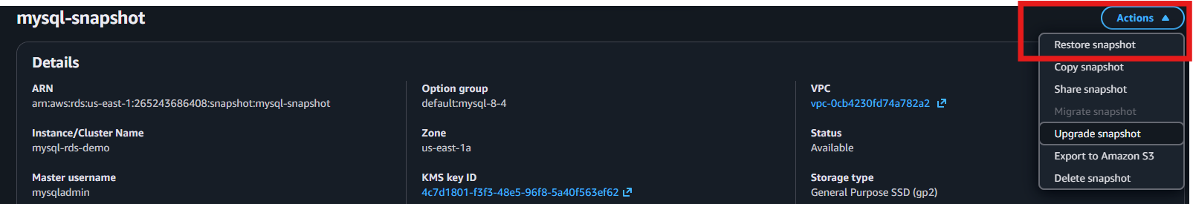
- Enter:
  - New DB instance identifier
  - VPC
  - Subnet group
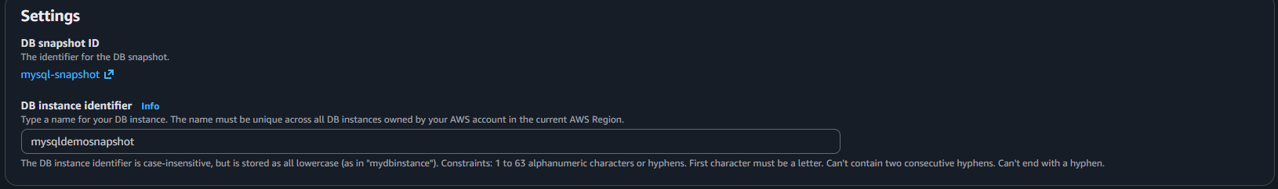
  - Security Group

- Click Restore DB Instance
AWS creates a new RDS MySQL instance with the same data. 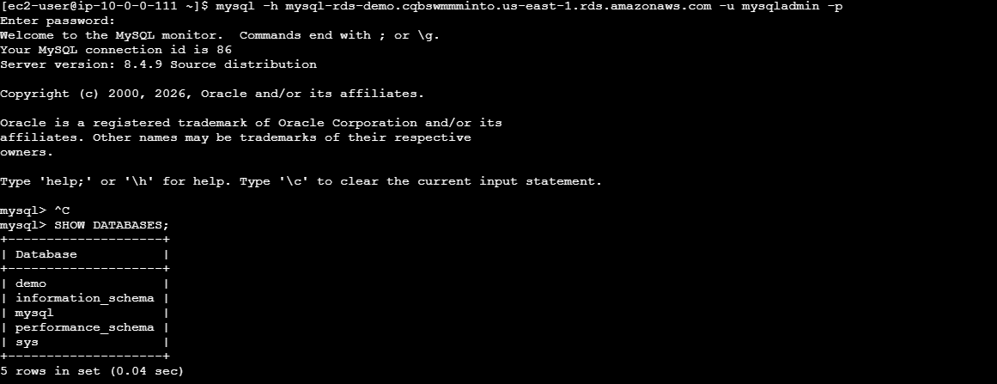

Verify
- Check new DB status:
RDS → Databases → Available
- Connect:
mysql -h mysqldemosnapshot.cqbswmmminto.us-east-1.rds.amazonaws.com -u admin -p
- Verify databases:
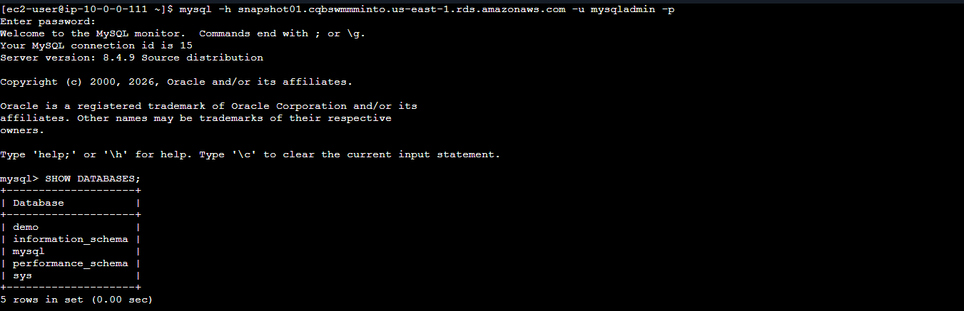
SHOW DATABASES;
✅ Backup = RDS Snapshot
✅ Restore = Create new RDS instance from snapshot

- Create read replica.
Create RDS MySQL Read Replica
- Go to RDS Console → Select MySQL DB Instance
- Click Actions → Create read replica
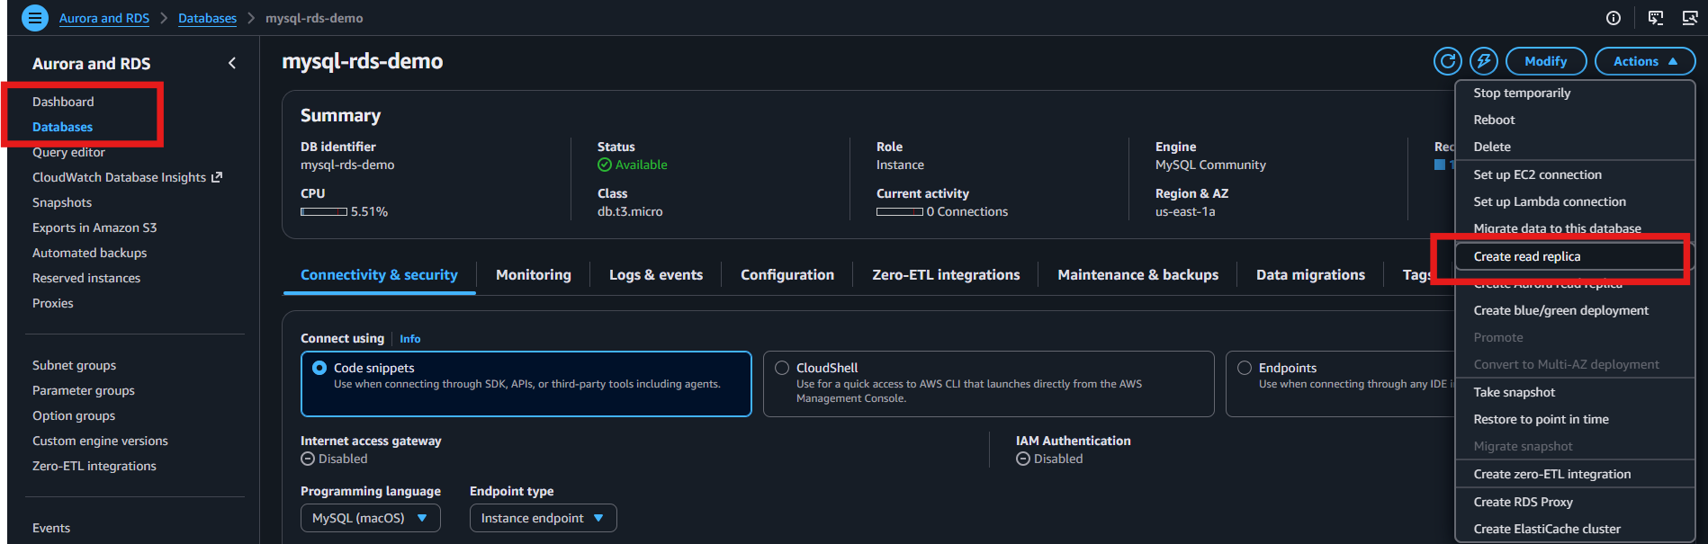
- Configure replica details (identifier, instance class, storage)
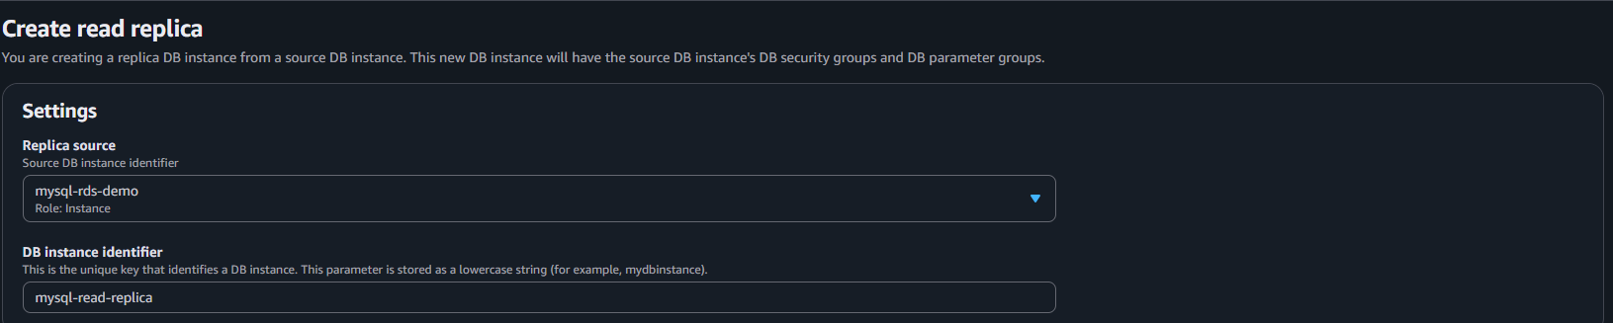
- Click Create read replica
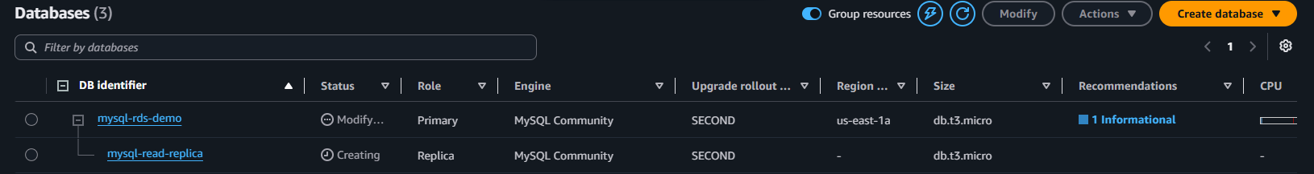
✅ Primary DB handles writes
✅ Read Replica handles read-only queries

